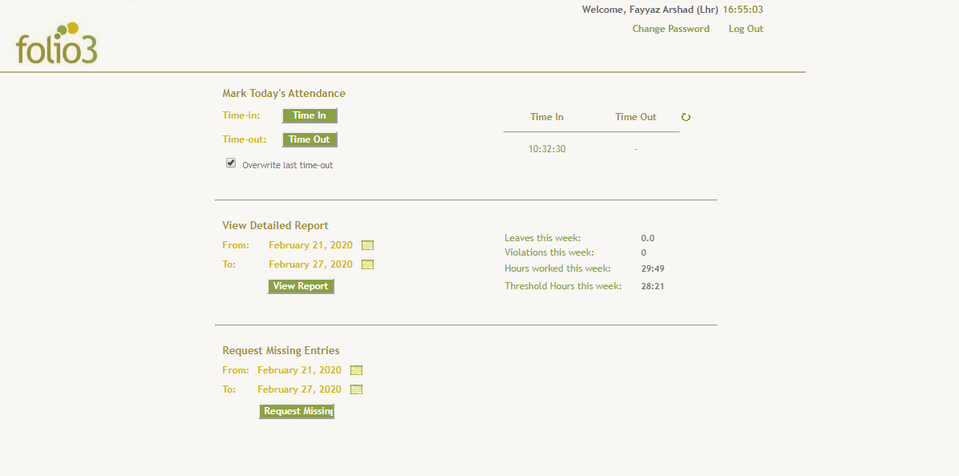

You have to create our attendance system using nodejs as server/backend and for frontend you can use simple html css and JavaScript. If you want to use any frontend framework like React/Angular/Vue, that would be plus. You can use MySQL database but you can also use any NOSQL database if you want.

**Requirements:**

All the features which you can explore by logging in to the system.

1. Login with valid credentials
2. Reset password
3. Time-in
4. Time-out
5. Attendance Report as per provided dates
6. Missing Entry Request